

Pune Vidyarthi Griha’s

COLLEGE OF SCIENCE AND TECHNOLOGY

Ghatkopar (East), Mumbai 400 077

**certificate**

This is to certify that this Term work book of Semester VI in the subject of Wireless Sensor Network submitted by Mr.: ONKAR PRAKASH MEJARI. Roll No: 19-320 for academic year 2021 -2022 complying with the requirements of University of Mumbai, for the course of B.Sc. Computer Science is accepted by the department.

_______________ ________________

**Internal Examiner External Examiner**

**Date: 28/03/22 College Seal**

**INDEX**

|  |  |  |  |
| --- | --- | --- | --- |
| **Sr No.** | **Practical’s** | **Date** | **Sign** |
| **1** | **Understanding the Sensor Node Hardware.** |  |  |
| **2** | **Exploring and understanding TinyOS computational concepts.** |  |  |
| **3** | **Understanding TOSSIM.** |  |  |
| **4** | **Implement a wireless sensor network simulation**. |  |  |
| **5** | **Create a MAC protocol simulation implementation for Wireless Sensor Network.** |  |  |
| **6** | **Simulate Mobile Adhoc Network with Directional Antenna.** |  |  |
| **7** | **Create a Mobile Network using Cell Tower, Central Office Server, Web Browser & Web Server.** |  |  |
| **8** | **Understanding, Reading & Analyzing, Routing Table of the Network.** |  |  |

**Practical no:-1**

**Aim:**

**1. Understanding the Sensor Node Hardware. (For Eg. Sensors, Nodes (Sensor**

**mote), Base Station, Graphical User Interface.)**

A Wireless sensor network (WSN) is a hardware and software package that typically consists of four parts:

a) 'Sensors' Connected to each node by a wired connection. In Our case, we use

Sensors that can measure soil moisture, electrical conductivity, soil temperature, water pressure, flow rate, or a range of weather variables (light, air temperature, wind, humidity, etc.).

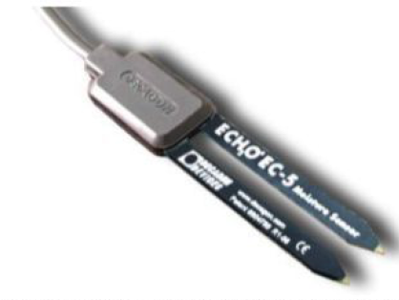

**ECHO EC-5 Moletore**

*One of many sensors that can be connected to a node, this EC-5 Sensor (Decagon Devices, Inc. Pullman, WA) Measures volumetric water content (soil moisture)*

b) 'Nodes' Collect the data from sensors and transmit that to a 'base station’ computer using a one way in the case of monitoring) or two-way (in the case of monitoring and control) radio. Nodes can simply monitor environmental and soil conditions or can be used to make control decisions. For example, some nodes have the capability to control an electric valve, such as an irrigation valve.

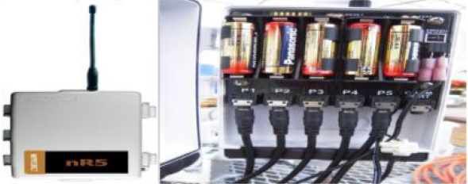

**Nr5 DECAGON DEVICE**

*This nR5 (Decagon Devices, Inc. Pullman, WA) Node is powered off of 5---AA Batteries and is connected to 5 Soil moisture sensors via stereo ports. The nR5 node is also capable of controlling irrigation valve(s), based on user---defined settings.*

c) 'Base Station Computer connects the system to the internet, so that data collected by the nodes, then transmitted to the base station computer, can be viewed anywhere an internet connection is available.

d) "Graphical User Interface' is the web---based software package, that allows the data collected

by sensors to be viewed. The Software is also used to set irrigation parameters.

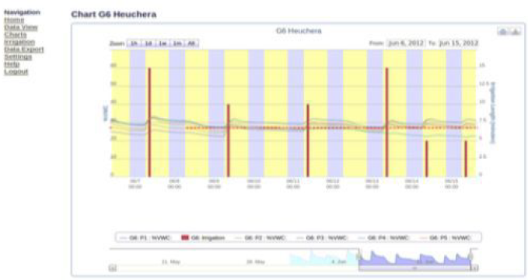

*The Graphical user interface above depicts the volumetric water content (soil moisture) as horizontal lines and irrigation events and amounts as bars. Notice the increase in soil moisture after each irrigation event.*

Not Every WSN will have all four components, but to get optimal functionality the systems developed as part of this project do. A Very simple WSN Example that many can relate to is that of the wireless environmental monitoring system used by the National Weather Service (NWS). You have probably seen these at a local airport or school. In This case, sensors measure environmental conditions and send this data to a node that wirelessly transmits the data using a cell signal or wireless signal to a base station computer where NWS Employees and you) can view the current temperature (or rainfall/dew point, wind, etc.) via a website or application ('app').

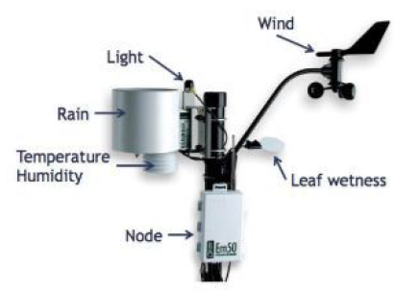

*Typical Environmental monitoring sensors that you would see at a National Weather Service (NWS) Monitoring station. These Same component scan be used in a wireless sensor network by a specialty crop producer*

**Practical no:-2**

**Aim:**

* **Exploring and understanding TinyOS computational concepts:- Events, Commands and Task.**

**- nesC model**

**- nesC Components**

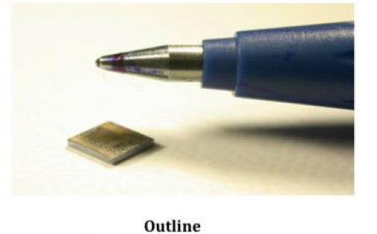

* Wireless sensor networks and TinyOS
* Networked embedded system (nesC)

- Components

- Interfaces Concurrency model

- Tool chain

* Issues / conclusion

**Wireless Sensor Networks**

* Vision: ubiquitous computing
* Extreme dynamics
* Interact with environment using sensors and radio
* Immense scale
* Limited access
* Small, cheap, low-power systems

**Concepts in Sensor Networks**

* In-network processing and data aggregation
* Radio activity 1000 times as expensive as processing
* Duty-cycling: different modes of operation
* Power down unused hardware
* Systems run a single application
* Applications are deeply tied to hardware
* Require customized and optimized OS

**Challenges**

* Limited resources: energy consumption dominates
* Concurrency: driven by interaction with environment
* Soft real-time requirements
* Reliability: reduce run-time errors, e.g. races
* High diversity of platforms
* No well-defined software/hardware boundary

**TinyOS**

* Component-based architecture
* Reusable system components: ADC, Timer, Radio
* Tasks and event-based concurrency .
* No user-space or context switching supported by hardware
* Tasks run to completion only preempted by interrupts
* All long-latency operations are split-phase
* Operation request and completion are separate functions

**Introducing nesC**

* A "holistic" approach to networked embedded systems
* Supports and reflects TinyOS's design
* Extends a subset of C
* A static language
* All resources known at compile-time .
* Call-graph fully known at compile-time

**Design Decisions for nesC**

* Components
* Bidirectional interfaces
* Simple expressive concurrency model
* Whole-program analysis

**Components**

* Challenge: platform diversity, flexible SW/HW boundary, applications deeply tied to

hardware.

* Encourages modular design
* Restrict access to private data
* Allow underlying implementations to be replaced easily
* Can abstract HW using thin wrappers
* Allow specialization of applications to hardware

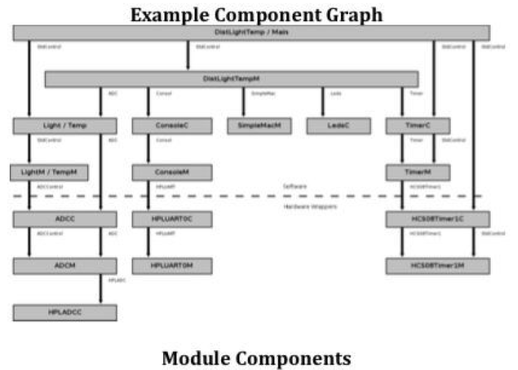

**Module Components**

* Modules implement application code
* Modules have private state
* Sharing of data among components is discouraged Convention:
* Module names end with 'M', e.g. BlinkM .
* Module variables start with 'm_’, e.g. m timers Configuration Components
* Configurations wire other components together
* All applications have a top-level configuration
* A component interface may be wired zero or more times
* Used for StdControl to implement power management
* Convention:
* Configuration names end with 'C', e.g. TimerC(unless it is the top-level configuration;)

**Modules and Configurations**

**/* BlinkM.nc */**

**module** BlinkM {

**provides interface** StdControl **as** Control;

**uses interface** Timer;

**uses interface** Leds;

} **implementation {**

**command** result_t Control.init() {

**call** Leds.init();

**return** SUCCESS;

}

**command** result_t Control.start() { /* ... */}

**command** result_t Control.stop() { /* ... */}

**event** result_t Timer.fired(){

**call** Leds.redToggle();

**return** SUCCESS;

}

**Practical no: - 3**

**Aim: Understanding TOSSIM for**

* **Mote-mote radio communication**
* **Mote-PC serial communication**

**Steps:**

**a) TOSSIM for Mote-mote radio communication**

**Introduction:**

TOSSIM is a discrete event simulator for TinyOS sensor networks. Instead of compiling a TinyOS application for a mote, users can compile it into the TOSSIM framework, which runs on a PC. This allows users to debug, test, and analyze algorithms in a controlled and repeatable environment. As TOSSIM runs on a PC, users can examine their TinyOS code using debuggers and other development tools. This document briefly describes the design philosophy of TOSSIM, its capabilities, its structure. It also provides a brief tutorial on how to use TOSSIM for testing or analysis.

TinyOS provides a number of interfaces to abstract the underlying communications services and a number of components that provide implement) these interfaces. All of these interfaces and components use a common message buffer abstraction, called message t, which is implemented as a nesC struct (similar to a C struct). The message t abstraction replaces the TinyOS 1.x TOS Msg abstraction. Unlike TinyOS 1.x, the members of message t are opaque, and therefore not accessed directly.

**Basic Communications Interfaces**

There are a number of interfaces and components that use message_t as the underlying data structure. Let's take a look at some of the interfaces that are in the tos/interfaces directory to familiarize ourselves with the general functionality of the communications system:

* Packet - Provides the basic accessors for the message_t abstract data type. This interface provides commands for clearing a message's contents, getting its payload length, and getting a pointer to its payload area.
* Send - Provides the basic address-free message sending interface. This interface provides commands for sending a message and canceling a pending message send. The interface provides an event to indicate whether a message was sent successfully or not. It also provides convenience functions for getting the message's maximum payload as well as a pointer to a message's payload area.
* Receive - Provides the basic message reception interface. This interface provides an event for receiving messages. It also provides for convenience, commands for getting a message's payload length and getting a pointer to a message's payload area
* PacketAcknowledgements - Provides a mechanism for requesting acknowledgements on a per packet basis.
* Radio TimeStamping - Provides time stamping information for radio transmission and reception.

**Components**

A number of components implement the basic communications and active message interfaces. Let's take a look at some of the components in the /tos/system directory. You should be familiar with these components because your code needs to specify both the interfaces your application uses as well as the components which provide (implement) those interfaces:

* AMReceiverC - Provides the following interfaces: Receive. Packet and AMPacket.
* AMSenderC - Provides AMSend, Packet, AMPacket, and PacketAcknowledgements as Acks.
* AMSnooperC - Provides Receive, Packet, and AMPacket.
* AMSnooningReceiverC - Provides Receive Packet and AMPacket.
* ActiveMessageAddressC - Provides commands to get and set the node's active message address. This interface is not for general use and changing a node's active message address can break the network stack, so avoid using it unless you know what you are doing.

**Compiling TOSSIM**

TOSSIM is a TinyOS library. Its core code lives in tos/lib/tossim. Every Tiny OS source directory has an optional sin subdirectory, which may contain simulation implementations of that package. For example, tos/chips/atm128/timer/sim contains TOSSIM implementations of some of the Atmega128 timer abstractions.

To compile TOSSIM, you pass the sim option to make:

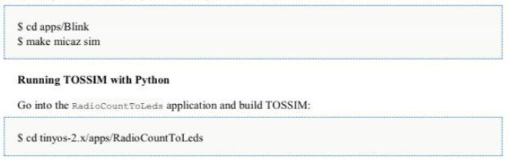

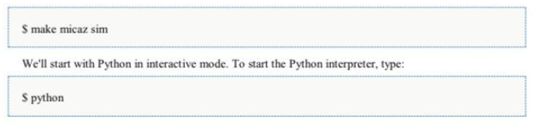

**b) TOSSIM for Mote-PC radio communication**

**Packet sources and TestSerial**

The first step is to check that you are able to get your PC to communicate with a mote. Most motes have a serial port or similar interface. For example, the mica family can directly control a serial port: programming boards basically connect the mote's serial port pins to the actual serial port on the board. Telos motes also have a serial interface, but it talks to their USB hardware, which is similar in functionality but very different in terms of cables and connectors.

The basic abstraction for mote-PC communication is a packet source. A packet source is exactly that: a communication medium over which an application can receive packets from and send packets to a mote. Examples of packet sources include serial ports, TCP sockets, and the SerialForwarder tool. Most TinyOS communication tools take an optional -comm parameter, which allows you to specify the nacket source as a string For example

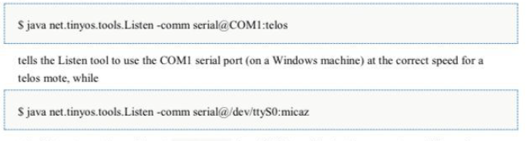

tells. Listen to use the serial port /dev/ttyso (on a UNIX machine) at the correct speed for a micaz mote. The first step to testing your serial port is to install the apps/tests/TestSerial application on a mote. This application sends a packet to the serial port every second, and when it receives a packet over the serial port it displays the packet's sequence number on the LEDs.

Once you have installed Test Serial, you need to run the corresponding Java application that communicates with it over the serial port. This is built when you build the Tiny OS application. From in the application directory, type:

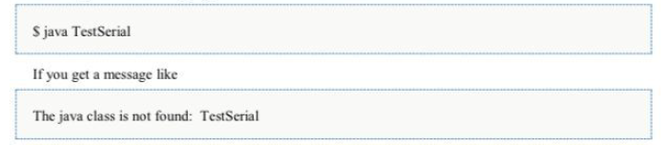

it means that you either haven't compiled the Java code (try running make platform again) or you don't have. (the current directory) in your Java CLASSPATH.

Because you haven't specified a packet source.Test Serial will fall back to a default, which is a SerialForwarder. Since you don't have a SerialForwarder running, TestSerial will exit, complaining that it can't connect to one. So let's specify the serial

port as the source, using the-comm parameter as described above. The syntax for a serial port source is as follows:

serial@<PORT> :< SPEED>

PORT depends on your platform and where you have plugged the mote in. For Windows Cygwin platforms, it is COMN, where N is the port number. For Linux/UNIX machines, it is /dev/ttysN for a built-in serial port, or one of /dev/ttyUSB or /dev/usb/tts/n for a serial-over-USB port. Additionally as we saw in lesson 1, on Linux you will typically need to make this serial port world writeable. As superuser, execute the following command:



The SPEED can either be a numeric value, or the name of a platform. Specifying a platform the serial packet source to use the default speed for the platform. Valid platforms are:

Platform Speed (baud)

______________________

Telos 115200

Telosb 115200

Tmote 115200

Micaz 57600

Mica2 57600

Iris 57600

Mica2dot 19200

Eyes 115200

Intelmote2 115200

The Java file support/sdk/java/net/tinyos/packet/BaudRate.java determines these mappings. Unlike in TinyOS 1.x, all platforms have a common serial packet format. Following the table, these two serial specifications are identical:

serial@COM1:micaz

serial@COM1:57600

If you run Test Serial with the proper PORT and SPEED settings, you should see output like this:

Sending packet 1

Received packet sequence number 4

Sending packet 2

Received packet sequence number 5

Sending packet 3

Received packet sequence number 6

Sending packet 4

Received packet sequence number 7

Received packet sequence number 8

**MOTECOM**

If you do not pass a -comm parameter, then tools will check the MOTECOM environment variable for a packet source, and if there is no MOTECOM, they default to a SerialForwarder. This means that if you’re always communicating with a mote over your serial port, you can just set MOTECOM and no longer have to specify the-comm parameter. For example:

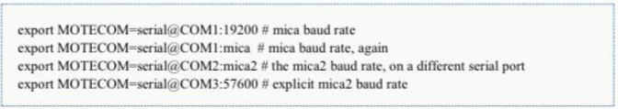

Try setting your MOTECOM variable and running TestSerial without a-comm parameter

**BaseStation and net.tinyos.tools.Listen**

BaseStation is a basic TinyOs utility application. It acts as a bridge between the serial port and radio network. When it receives a packet from the serial port, it transmits it on the radio; when it receives a packet over the radio, it transmits it to the serial port. Because TinyOS has a toolchain for generating and sending packets to a mote over a serial port, using a Base Station allows PC tools to communicate directly with mote networks.

Take one of the two nodes that had BlinkToRadio (from lesson 3) installed and install Base Station on it. If you turn on the node that still has BlinkToRadio installed, you should see LED 1 on the BaseStation blinking. BaseStation toggles LED 0 whenever it sends a packet to the radio and LED 1 whenever it sends a packet to the serial port. It toggles LED 2 whenever it has to drop a packet: this can happen when one of the two receives packets faster than the other can send them (e.g., receiving micaZ radio packets at 256kbps but sending serial packets at 57.6kbps).

Base Station is receiving your BlinkToRadio packets and sending them to the serial port, so if it is plugged into a PC we can view these packets. The Java tool Listen is a basic packet sniffer: it prints out the binary contents of any packet it hears. Run Listen, using either MOTECOM or a -comm parameter



Listen creates a packet source and just prints out every packet it sees. Your output should look something like this:

00 FF FF 00 00 04 22 06 00 02 00 01

00 FF FF 00 00 04 22 06 00 02 00 02

00 FF FF 00 00 04 22 06 00 02 00 03

00 FF FF 00 00 04 22 06 00 02 00 04

00 FF FF 00 00 04 22 06 00 02 00 05

00 FF FF 00 00 04 22 06 00 02 00 06

00 FF FF 00 00 04 22 06 00 02 00 07

00 FF FF 00 00 04 22 06 00 02 00 08

00 FF FF 00 00 04 22 06 00 02 00 09

00 FF FF 00 00 04 22 06 00 02 00 OA

00 FF FF 00 00 04 22 06 00 02 00 OB

Listen is simply printing out the packets that are coming from the mote. Each data packet that comes out of the mote contains several fields of data. The first byte (00) indicates that this is packet is an AM packet. The next fields are the generic Active Message fields, defined in tinyos which was defined in BlinkToRadio as:

typedef nx_struct BlinkToRadio Msg {

nx uint16_t nodeid;

nx uint16_t counter;

} BlinkToRadio Msg;

The overall message format for the BlinkToRadioC application is therefore (ignoring the first 00 byte):

**• Destination address (2 bytes)**

**• Link source address (2 bytes)**

**• Message length (1 byte)**

**• Group ID (1 byte)**

**• Active Message handler type (1 byte)**

**• Payload (up to 28 bytes):**

* source mote ID (2 bytes)
* sample counter (2 bytes)

So we can interpret the data packet as follows:





The link source address and source address field differ in who sets them. The serial stack does not set the link source address: for Blink, it should always be 00 00. Blink sets the source address to be the node's ID, which depends on what mote ID you installed your BlinkToRadio application with. The default (if you do not specify and ID) is 00 01. Note that the data is sent by the mote in *big- endian format*, for example, 01 02 means 258 (256*1 + 2). This format is independent of the endianness of the processor, because the packet format is an nx struct, which is a network format, that is, big-endian and byte-aligned. Using nx_struct (rather than a standard C struct) for a message payload ensures that it will work across platforms.

As you watch the packets scroll by, you should see the counter field increase as the BlinkToRadio app increments its counter.

**Practical No: - 4**

**Aim:** Implement a wireless sensor network simulation.

**Requirements:** 2 PC (PT); 1 ACCESS POINT (PT-A); 1 LAPTOP (PT); 1 SERVER (PT).

**STEPS:**

**1]** Click on PC (0), turn off CPU & remove the pre-installed module now place the **PT-HOST-NM-1W-A**

module & switch-on the CPU.

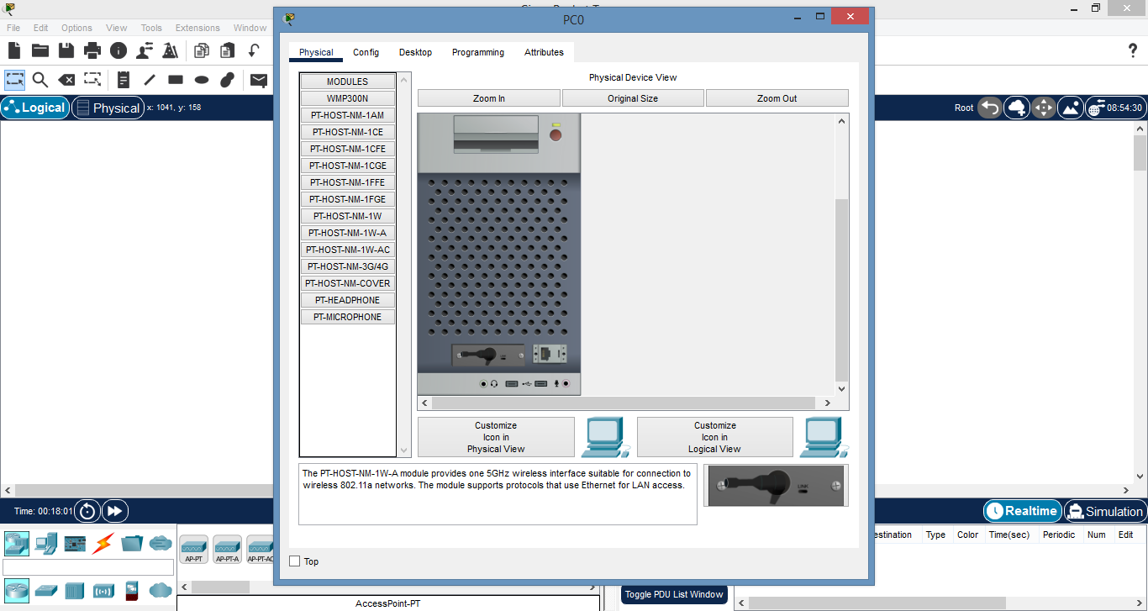

**2]** Now click on the second PC i.e. PC (1) & repeat the initial step.

**3]** Now we can see the connection link between the PCs & the access point (PT-A).

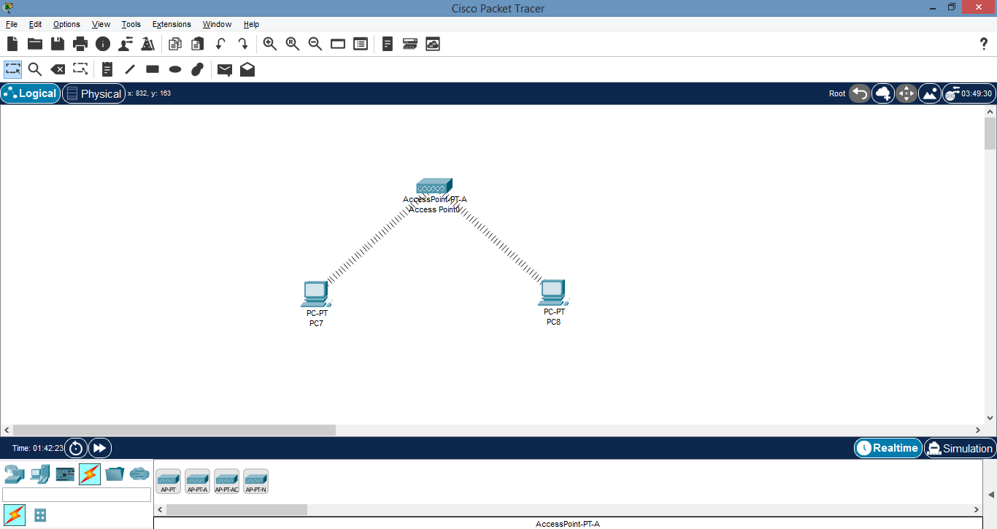

**4]** Again click on PC (0) and in the desktop tab open IP Configuration, switch the state from DHCP to Static

and set the IP address.

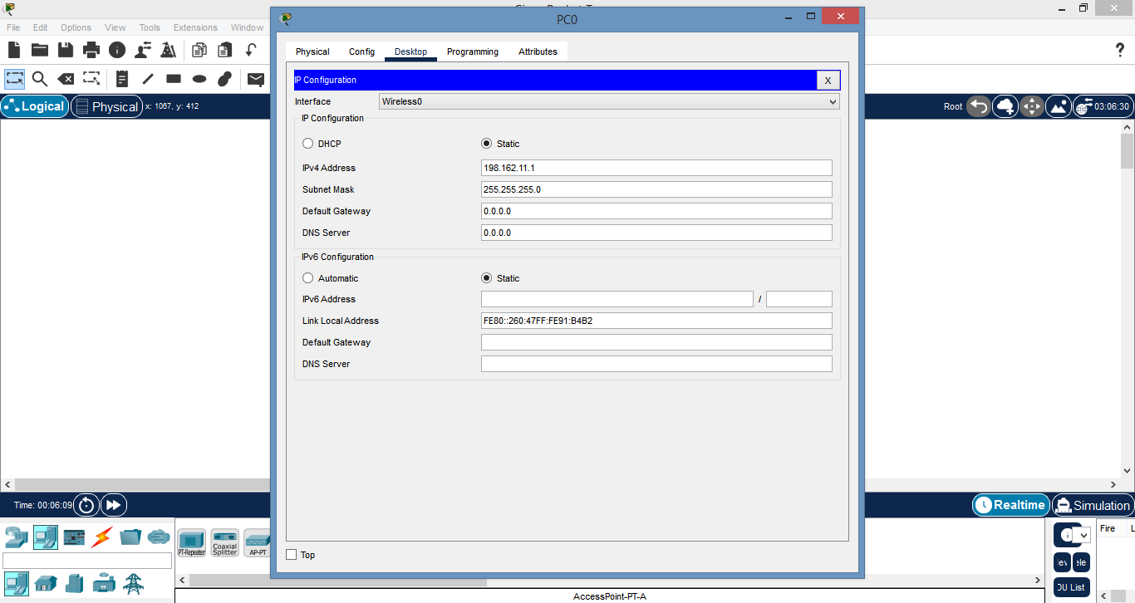

**5]** Similarly do the same procedure for PC (1).

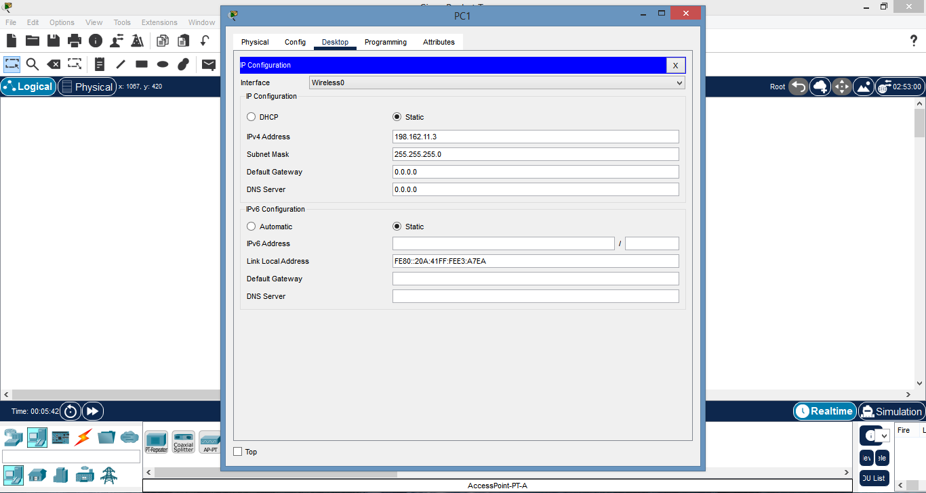

**6]** After setting the IP addresses of both the PC click on PC (0), in the desktop tab click on **COMMAND**

**PROMPT &** type the command: “*ping IP address of PC (1)*”.

**7]** If the pinging is successful then we get the following output:

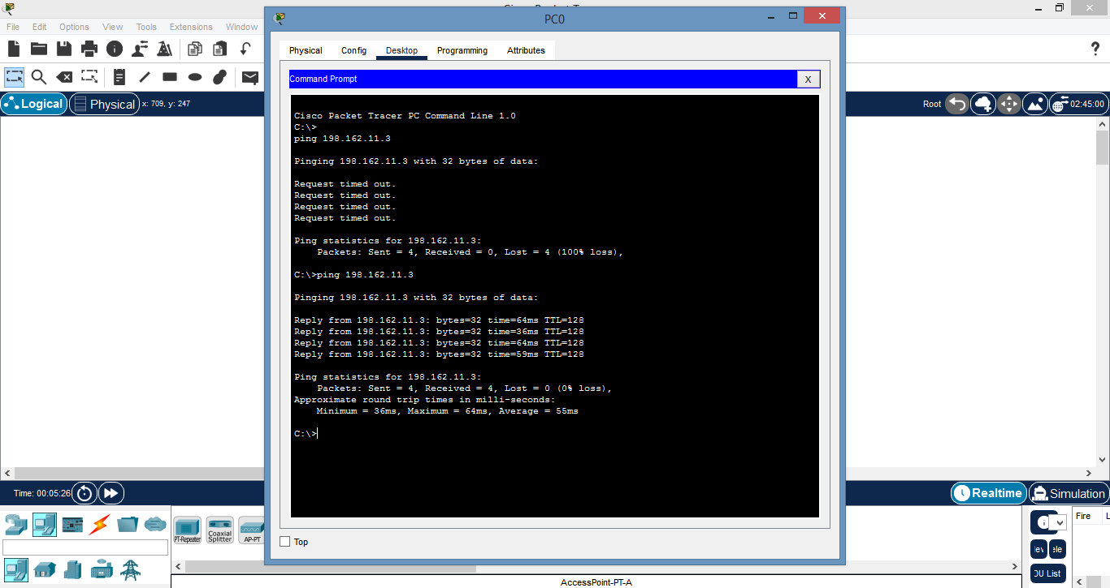

**8]** Now for the laptop also again we have to change the module and install the **PT-LAPTOP-NM-1W-A**

module and switch on the laptop.

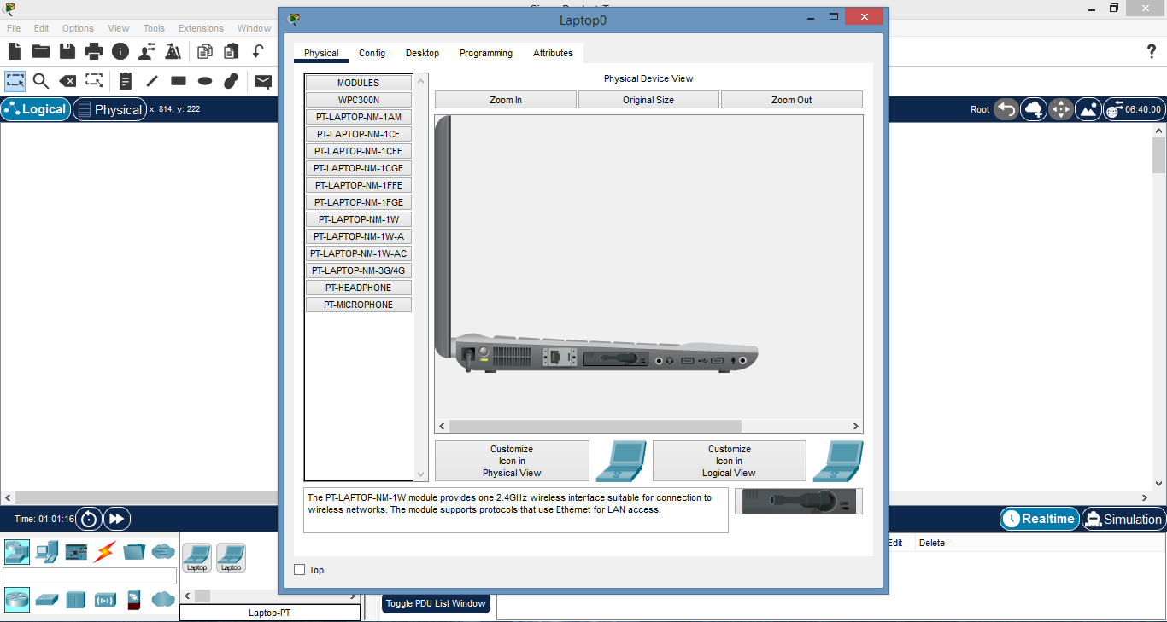

**9]** Now we can see the connection between the laptop and the access point (PT-A).

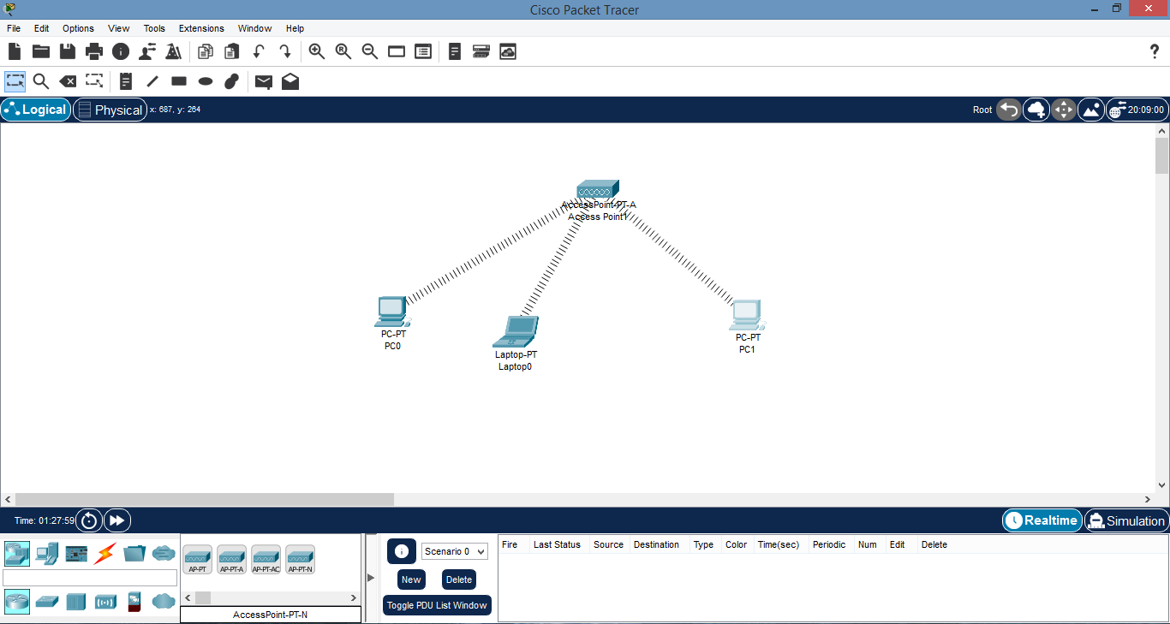

**10]** Now set the IP address of laptop by clicking on desktop tab.

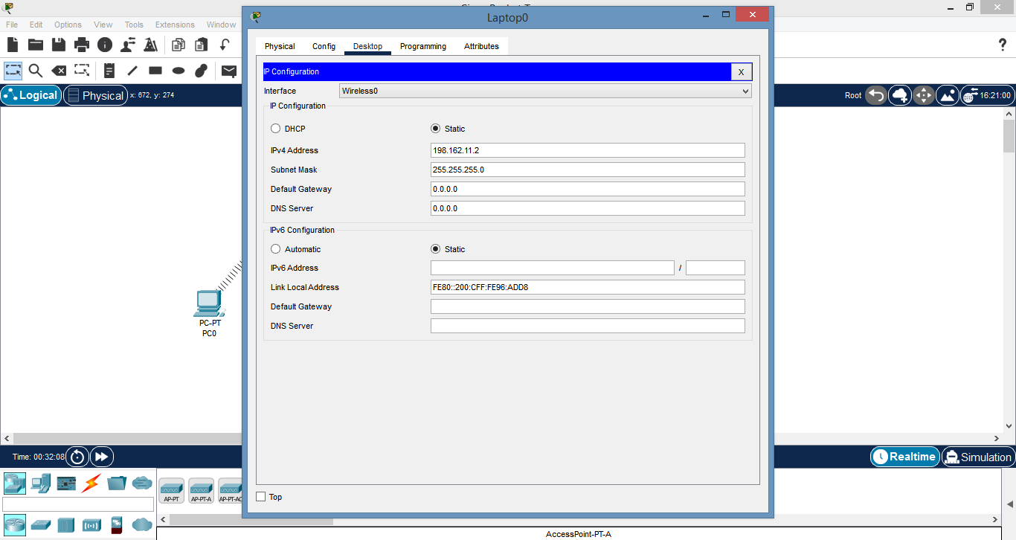

**11]** At last click on server and similarly change the existing module with **PT-HOST-NM-1W-A** & switch-on

the server.

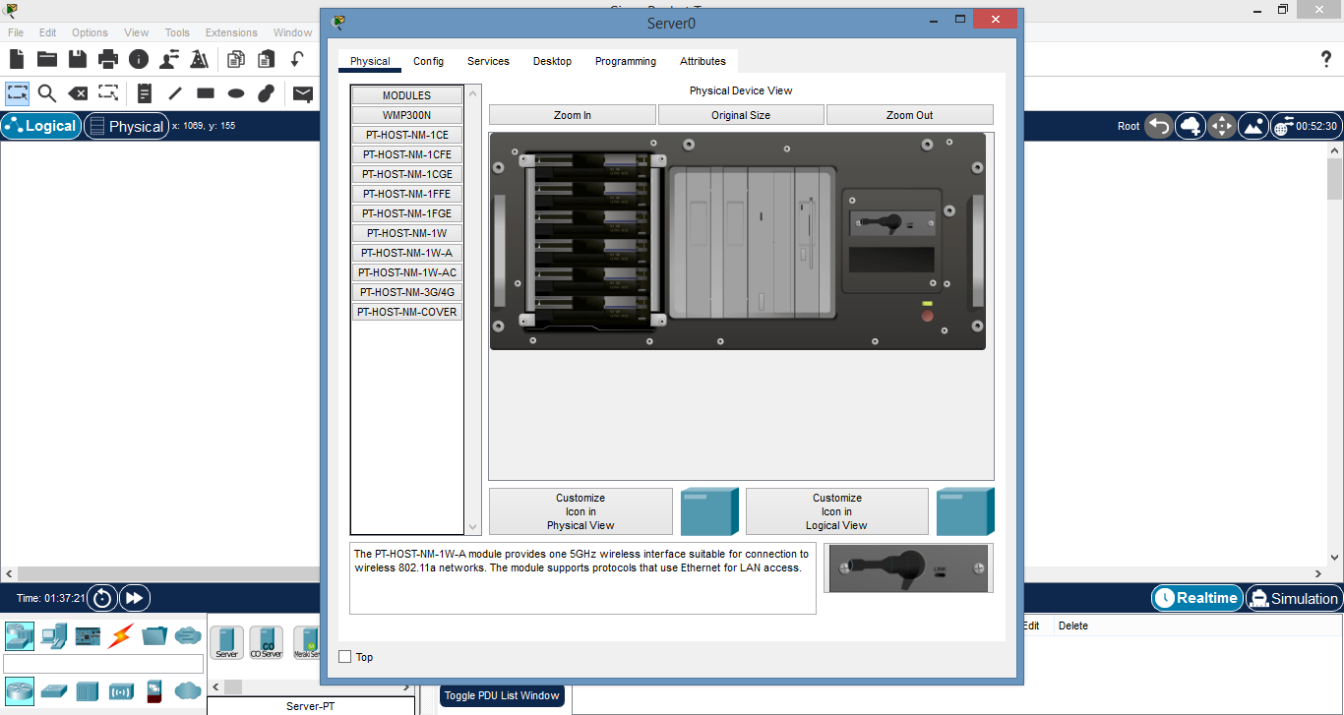

**12]** A connection link between server and access point is formed.

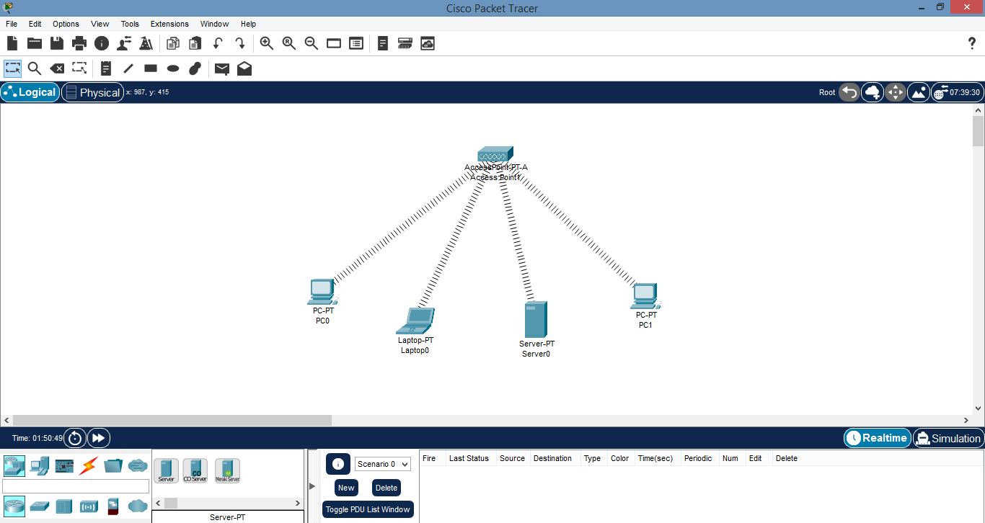

**13]** Set the IP address by clicking on the desktop tab.

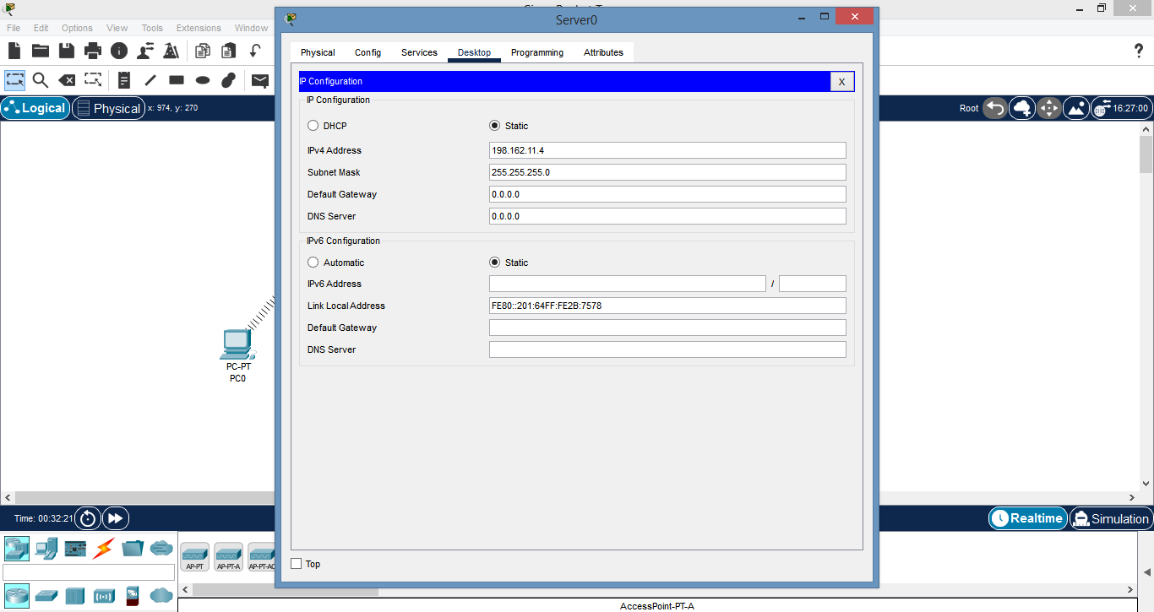

**14]** Now click on laptop and go to command prompt by clicking on desktop tab & try to execute the following

command “*ping IP address of server*”.

**15]** If the pinging succeeds then we will get the following output:

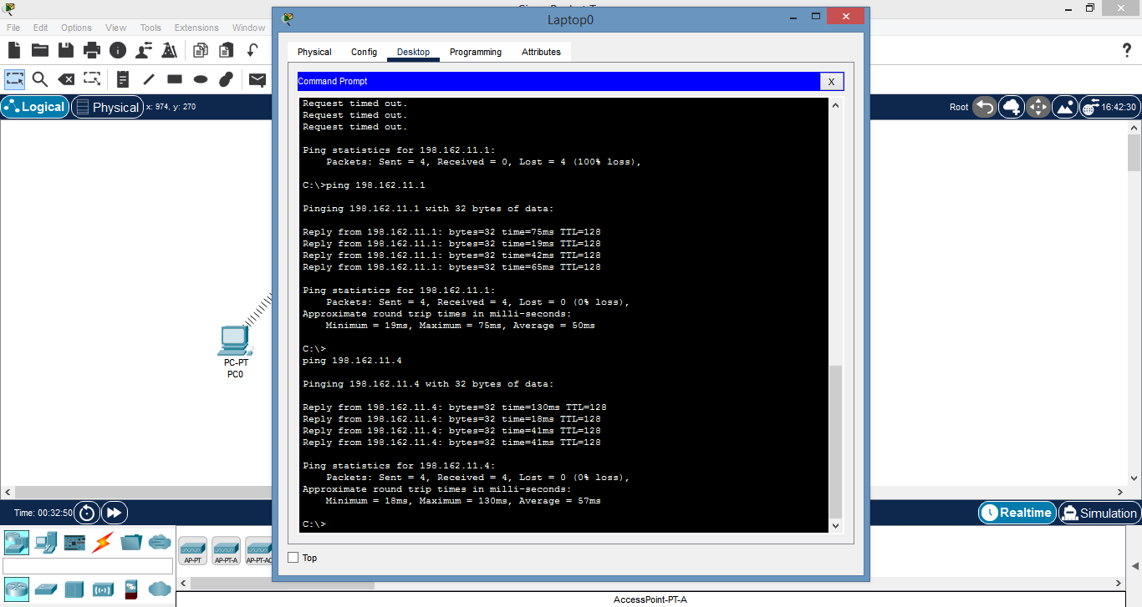

**16]** Finally try to ping the IP address of both the PC from laptop if it succeed then we will get the ultimate

output as:

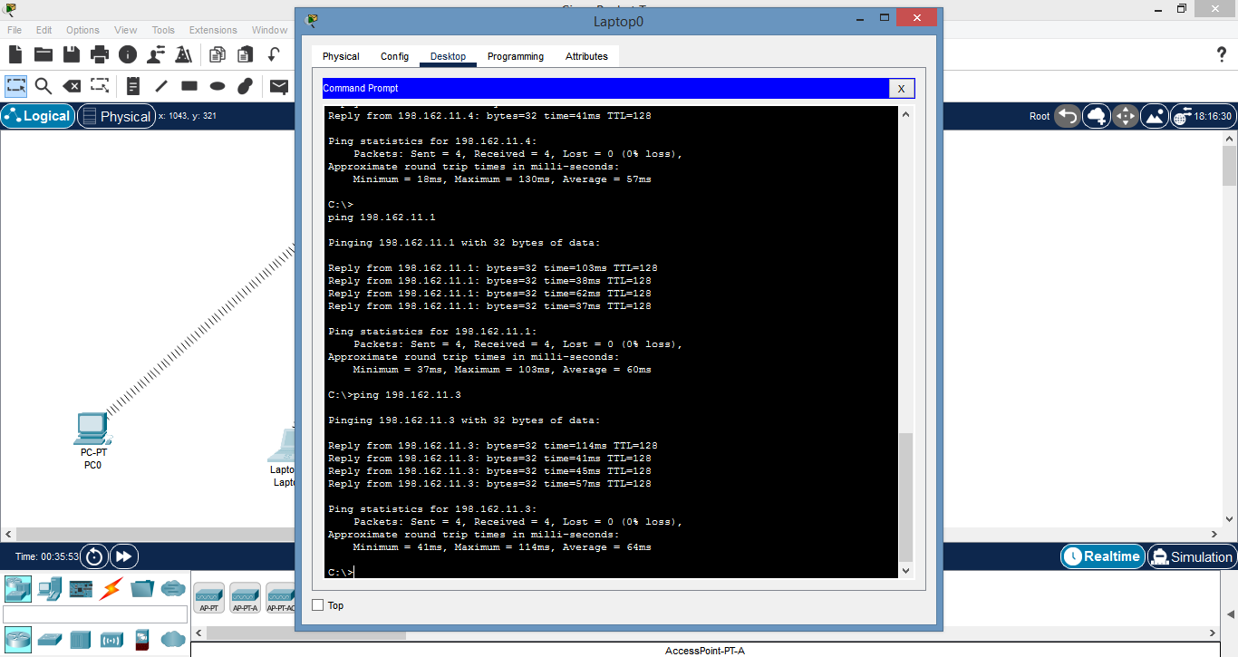

**PRACTICAL NO: - 5**

**Aim:** Create a MAC protocol simulation implementation for Wireless Sensor Network.

**Requirements:** 1 WIRELESS ROUTER [WRT300N]; 2 LAPTOP (PT); 2 TABLET (PT); 2 SMARTPHONE (PT)

**STEPS:**

**1]** First click on LAPTOP (0) and go in physical tab and change the existing module with

PT-HOST-NM-1W.

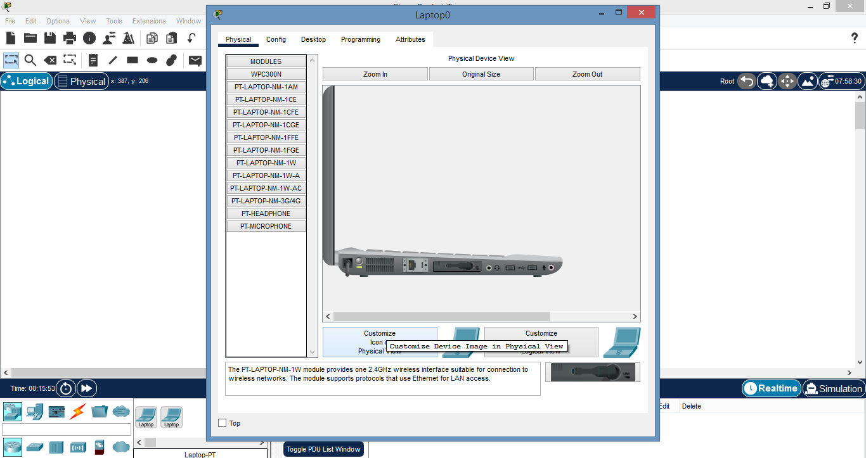

**2]** Do this for all the laptop.

**3]** A connection between laptop, smartphone & tablet is formed.

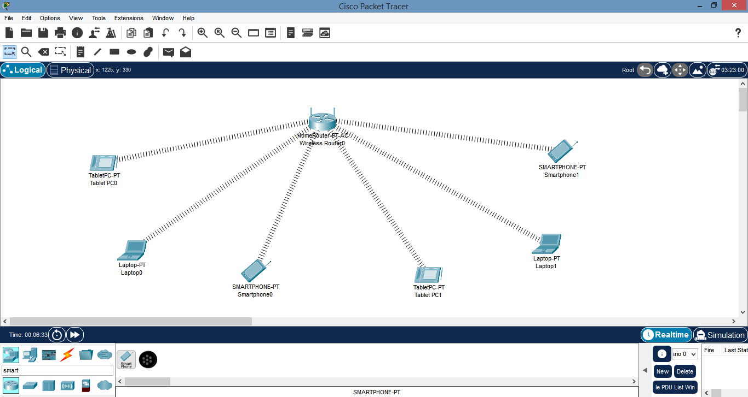

**4]** Copy the MAC protocol of each component by clicking on the config tab.

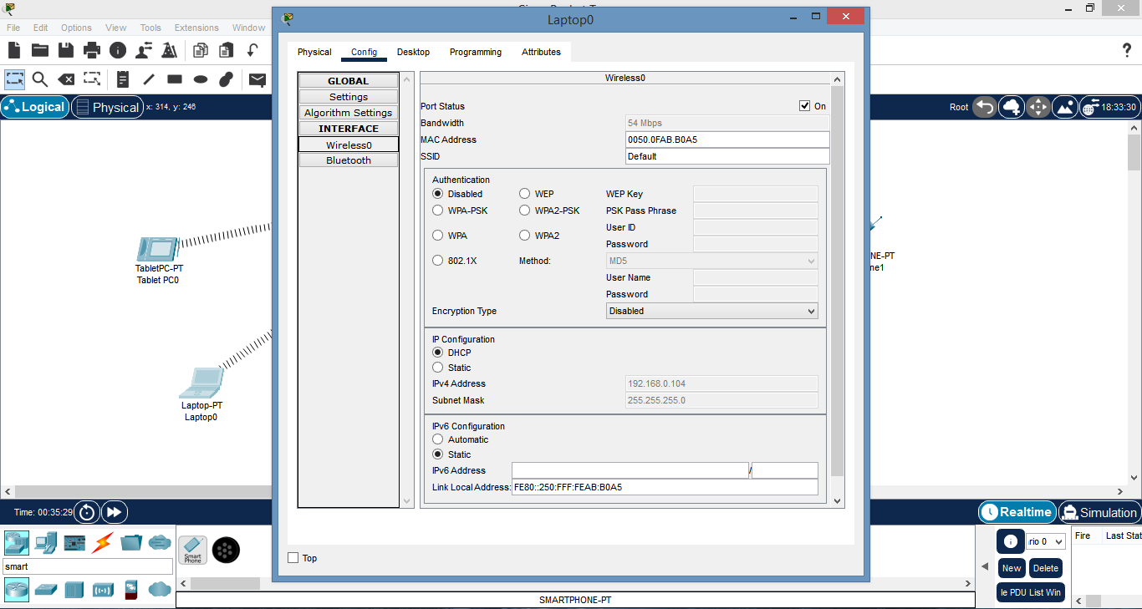

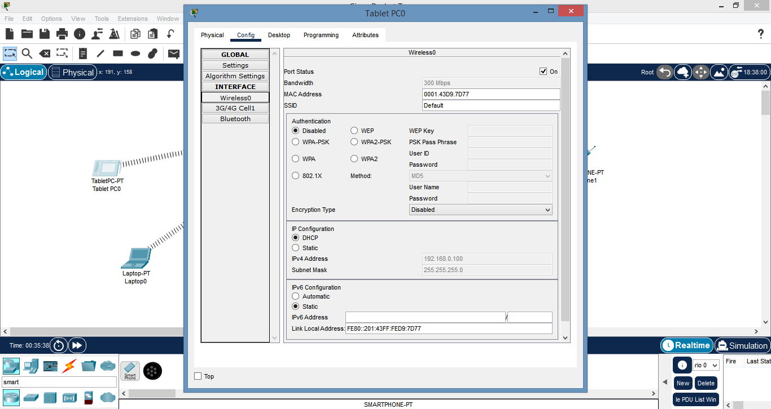

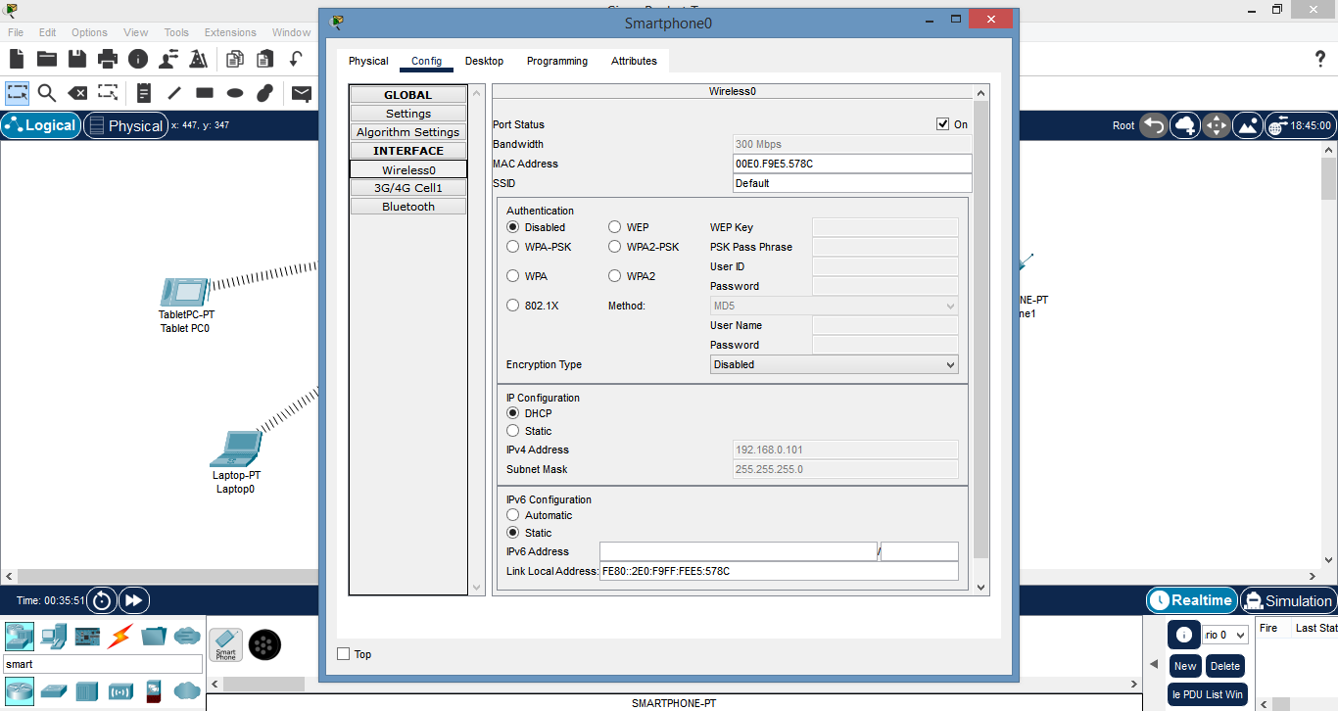

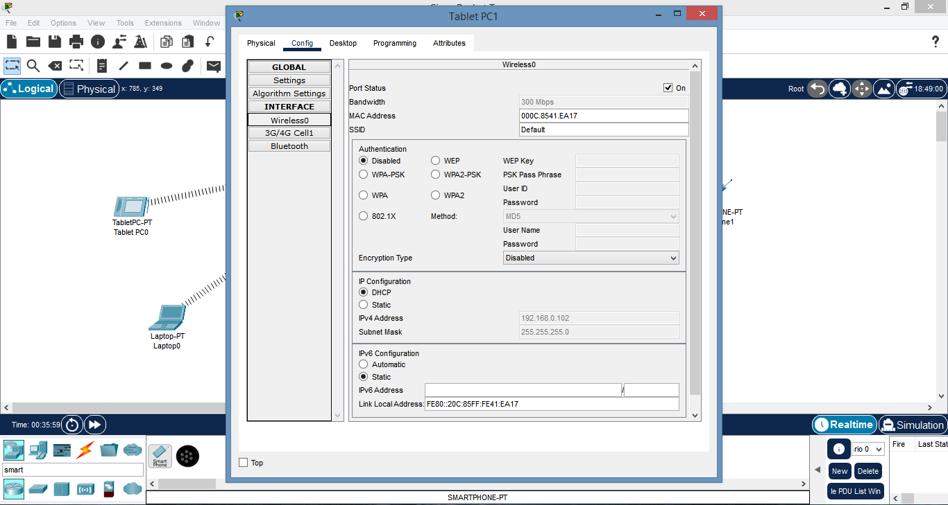

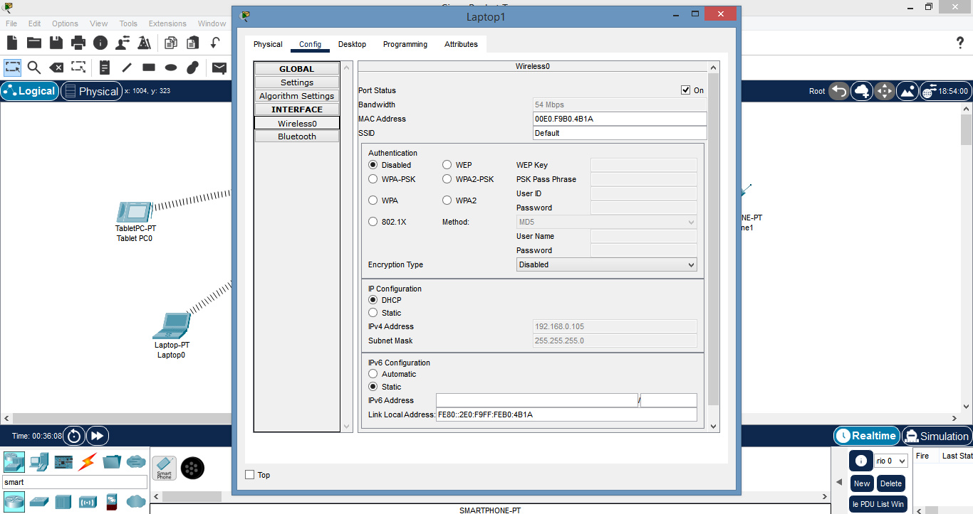

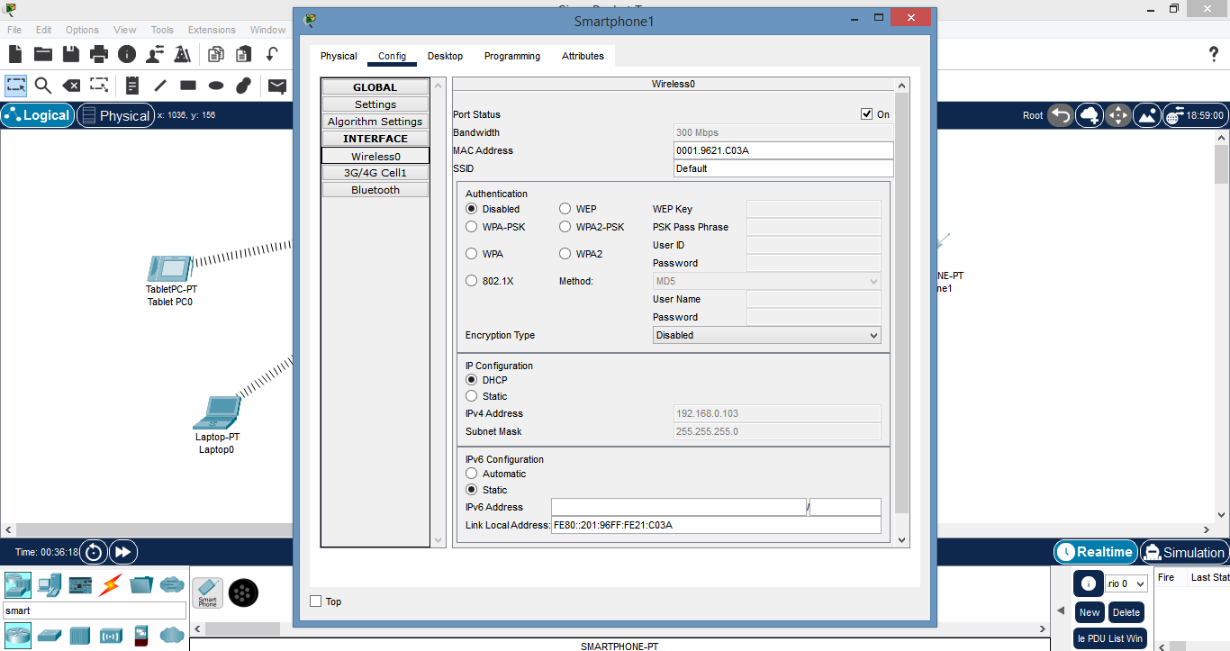

**5]** We have note the following MAC addresses and convert them to the following form:

|  |  |  |
| --- | --- | --- |
| Component | MAC Address | Converted MAC Address |
| Laptop 0 | 0050.0FAB.B0A5 | 00:50:0F:AB:B0A5 |
| Tablet PC 0 | 0001.43D9.7D77 | 00:01:43:D9:7D:77 |
| Smartphone 0 | 00E0.F9E5.578C | 00:E0:F9:E5:57:8C |
| Tablet PC 1 | 000C.8541.EA17 | 00:0C:85:41:EA:17 |
| Laptop 1 | 00E0.F9B0.4B1A | 00:E0:F9:B0.4B:1A |
| Smartphone 1 | 0001.9621.C03A | 00:01:96:21:C0:3A |

**6]**  Now we add few addresses in the wireless MAC filter of the Wireless Router & then use the given option for either

allow or deny the Wireless access.

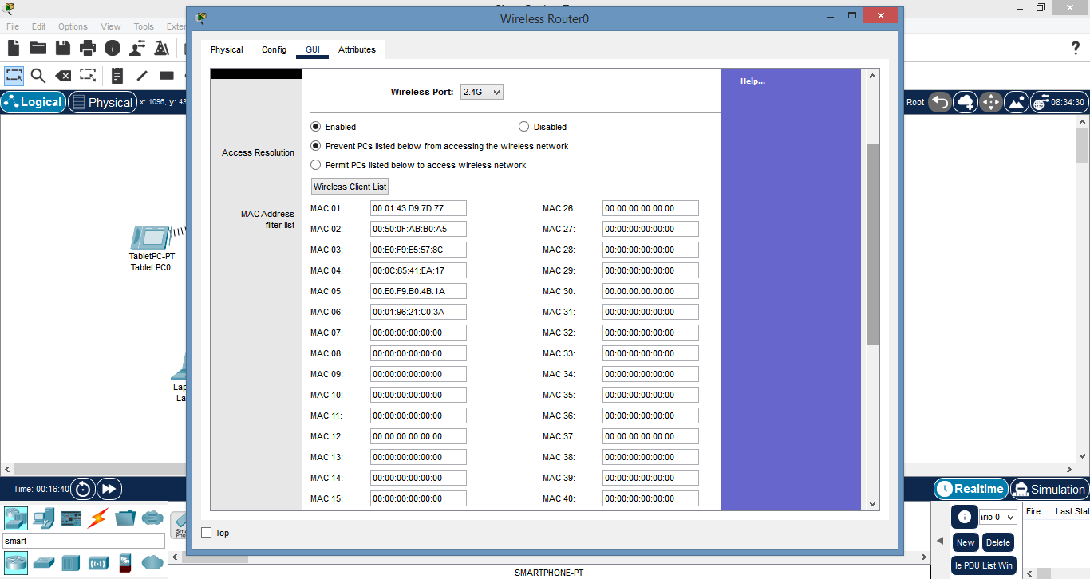

**7]** As seen in above screen shot we add the MAC address of the entire component in the list as to deny

them accessing the Wireless network and then save the settings.

**8]** The result so obtained is as sown, the devices denied any wireless connectivity.

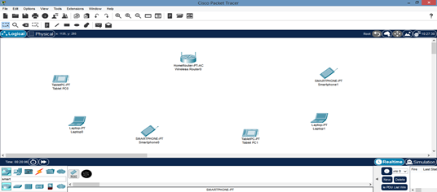

**Practical No: - 6**

**Aim:** Simulate Mobile Adhoc Network with Directional Antenna.

**Requirements:** 1 FAN, 1 MOTION SENSOR, HOME GATEWAY, 1 SMARTPHONE, 1 AC.

**STEPS:**

**1]** First click on the FAN & do the following.

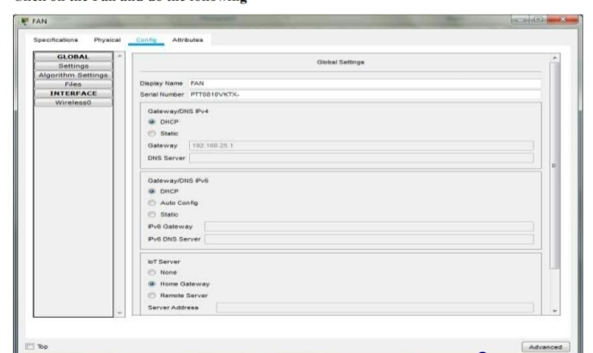

**2]** In the Advanced setting do the following for the Network adapter.

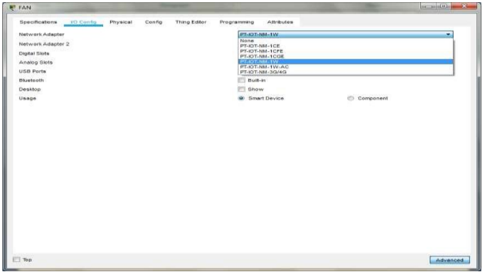

**3]** For the motion Detector sensor do the following.

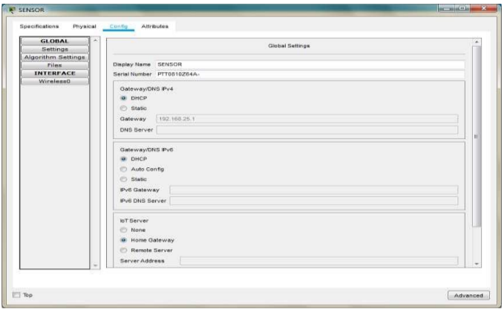

**4]**  In the advanced setting do the following for the Network adapter.

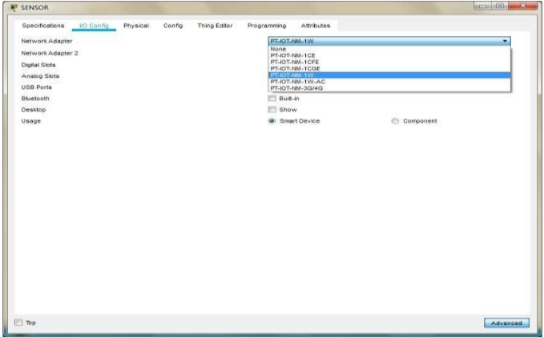

**5]** For the smartphone change the SSID to the SSID in the Home Gateway0.

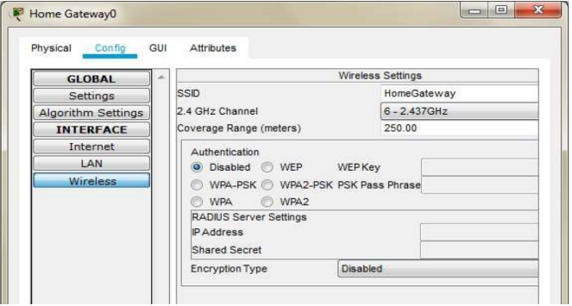

**6]** As seen above the SSID is Home Gateway, we use the same and set the SSID in the Smartphone.

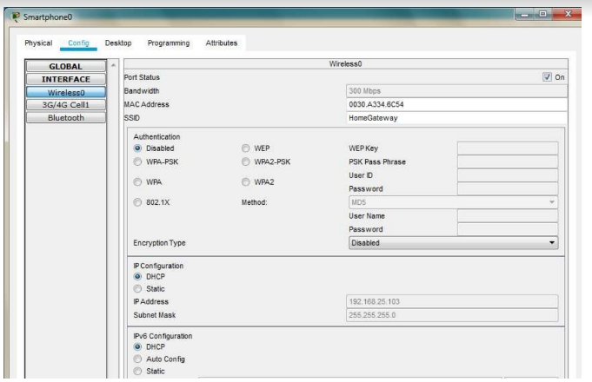

**7]** All the devices are now connected to the Home Gateway.

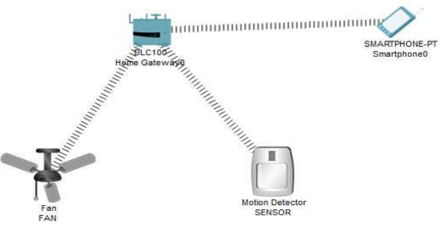

**8]** Now open the Web browser of the Smart Phone and type the IP address of the Home Gateway.



**9]** After logging click on conditions and do the following. 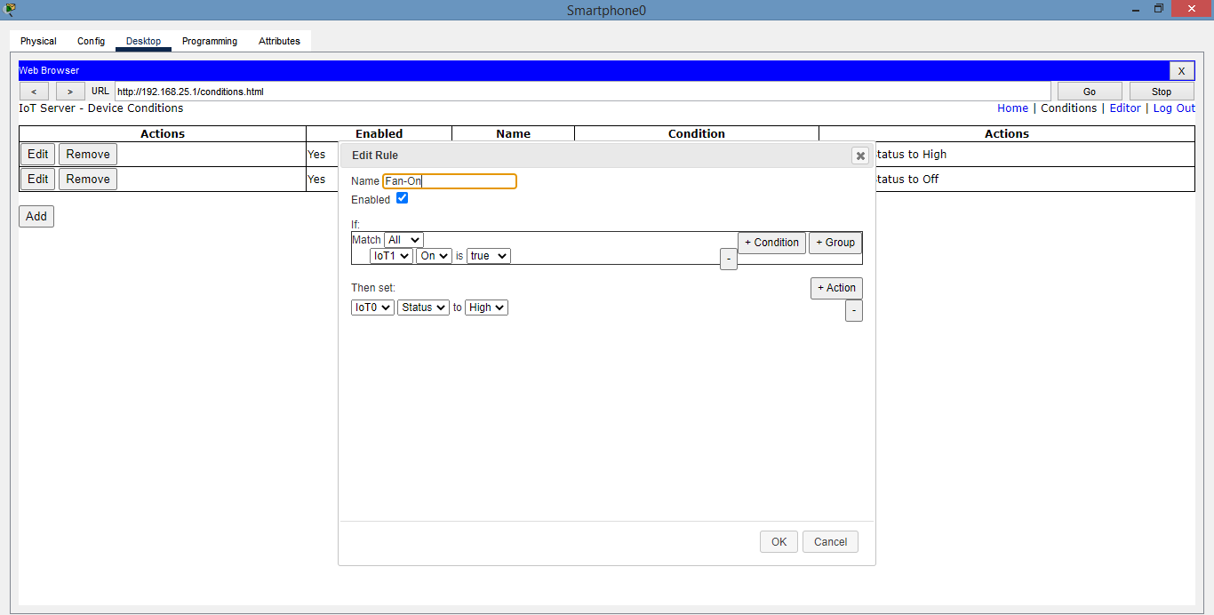

**10]** Add another condition as follows.

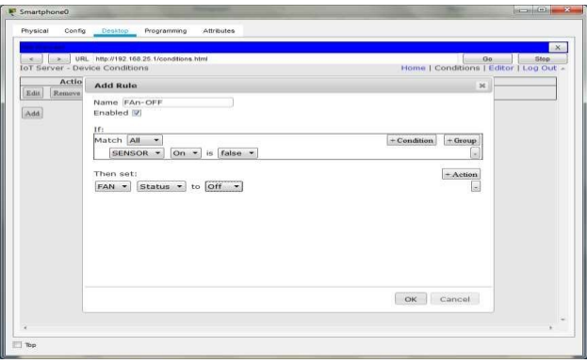

**11]** Press the go button after adding the two conditions.

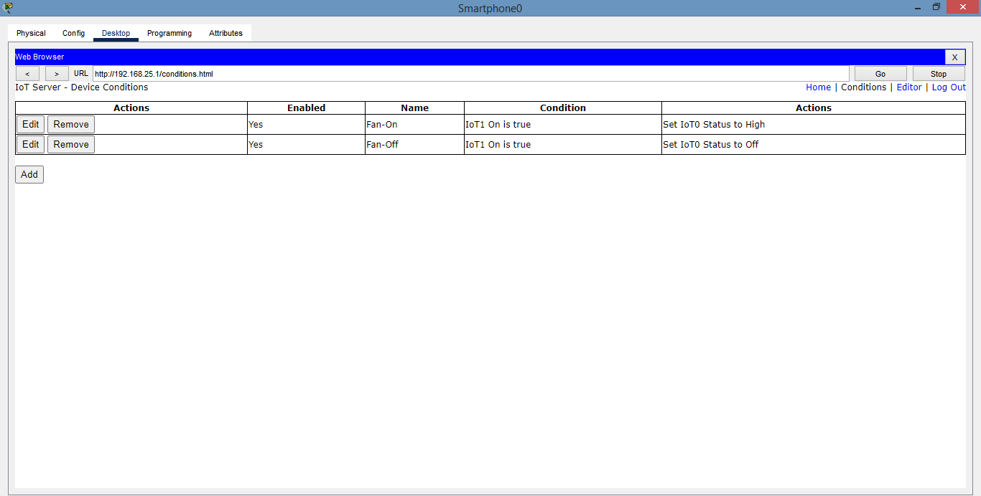

**12]** In order to turn ON the fan Press the ALT key and left-click the mouse over the

Sensor.

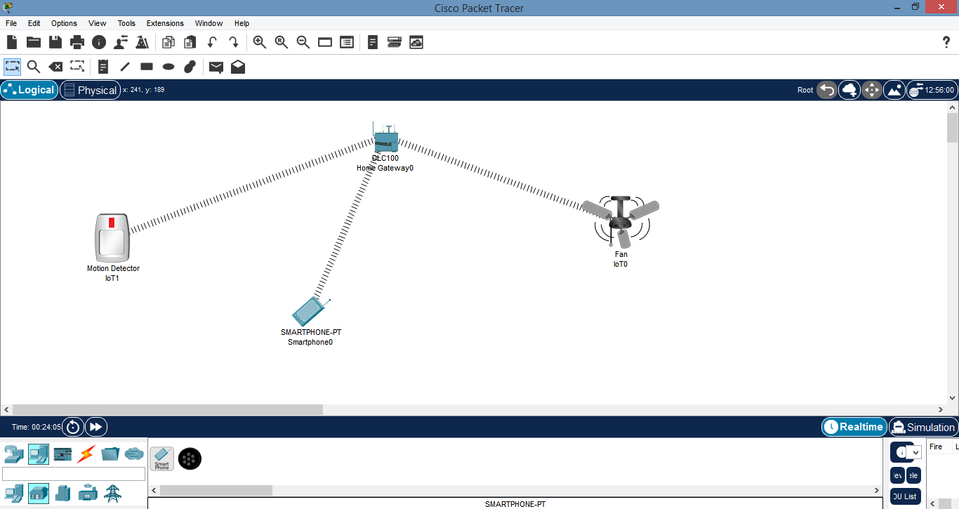

**13]** Now click on AC and do the same process as carried out in FAN.

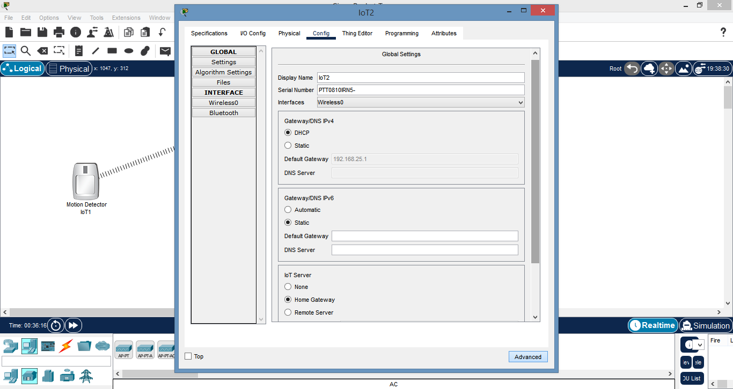

**14]** In the advanced setting do the following for the network adapter.

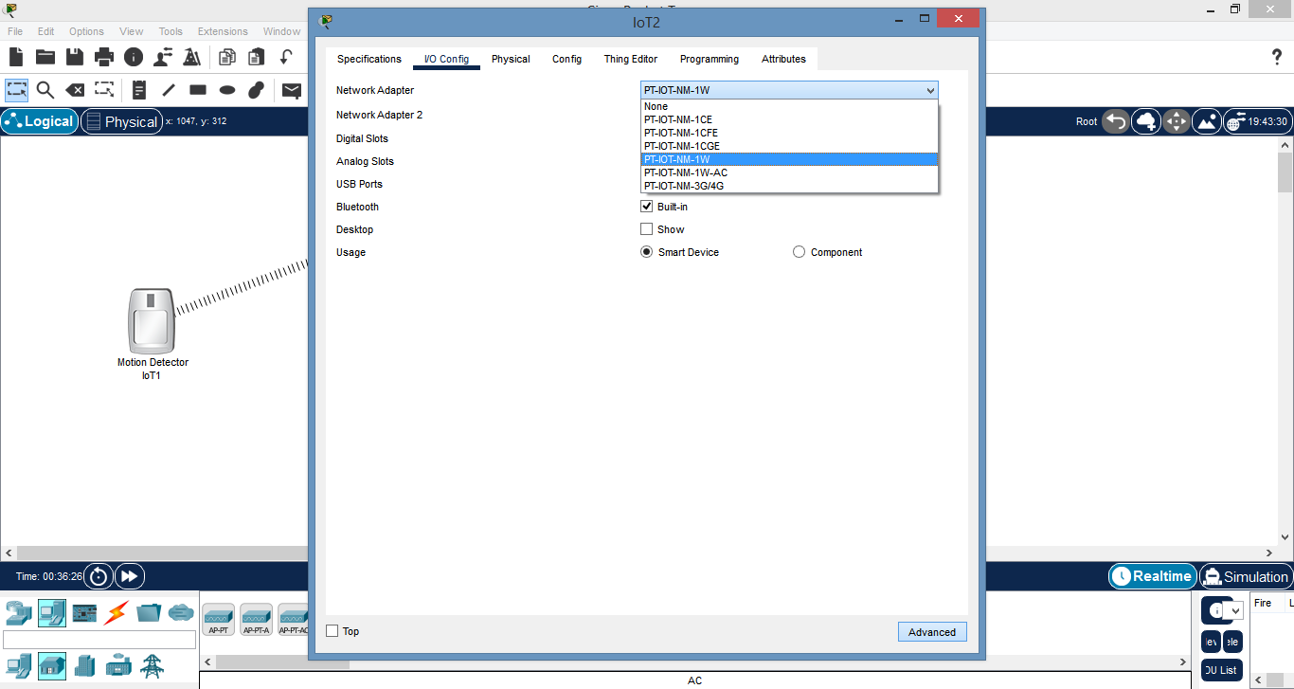

**15]** All the devices are now connected to the Home Gateway.

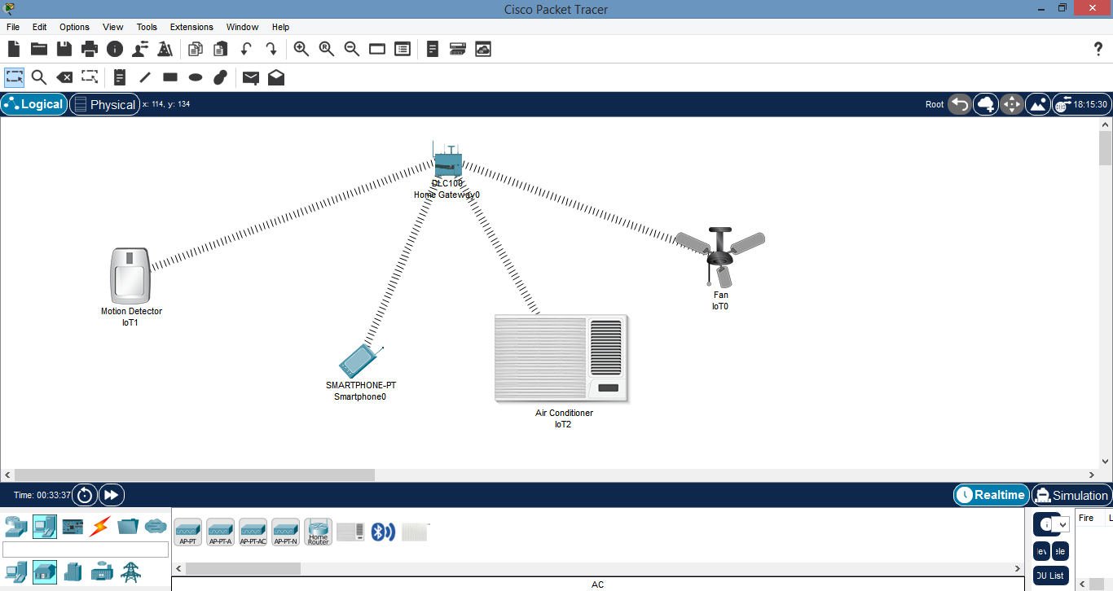

**16]** Now give the conditions for switching-on & off theAC.

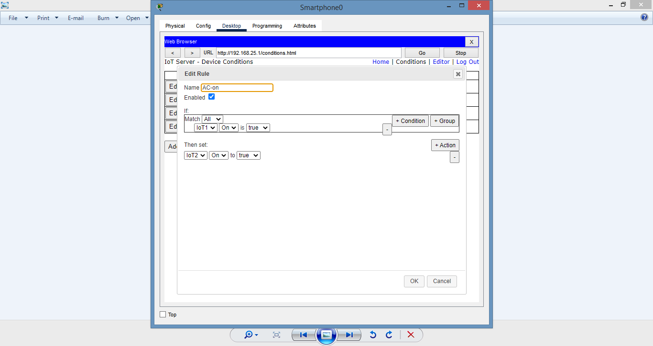

**17]** After clicking on go you would able to see all the 4 conditions.

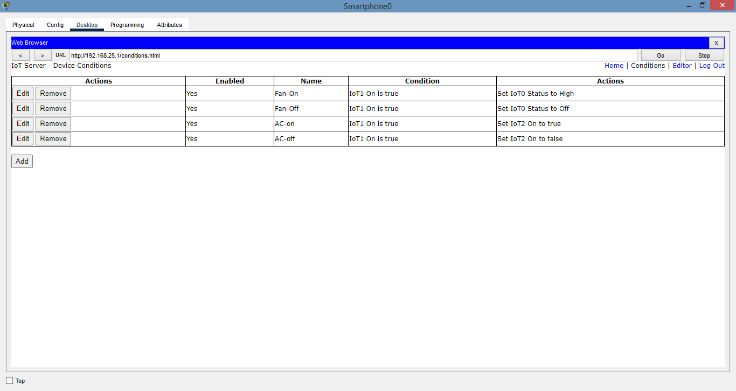

**18]** In order to turn ON the FAN & AC press the ALT key and left-click the mouse over the Sensor.

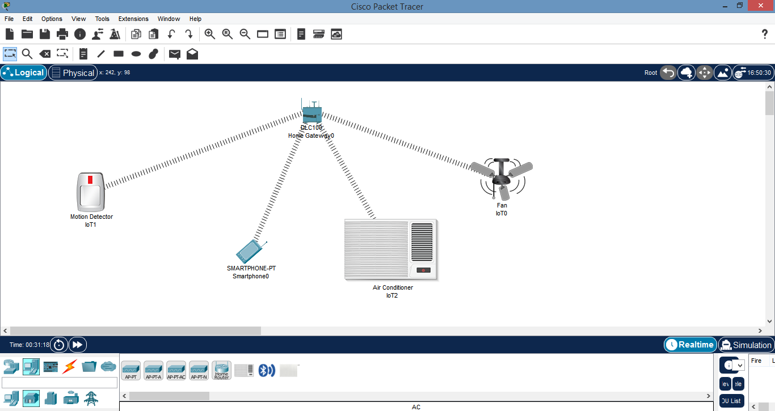

**Practical No: - 7**

**Aim:** Create a Mobile Network using Cell Tower, Central Office Server, Web Browser &

Web Server. Simulate connection between them.

**Requirements:** 1 CENTRAL OFFICE SERVER [CO], 1 CELL TOWER, 1 WIRELESS ROUTER [WRT300N],

1 HUB PT, 1 1841 ROUTER.

**STEPS:**

**1]** Createa network using smartphone, wireless router WRT300N, Hub-pt, 1841 Router, central office server, Cell-Tower.

**2]** Connect cell tower and central office server using coaxial cable.

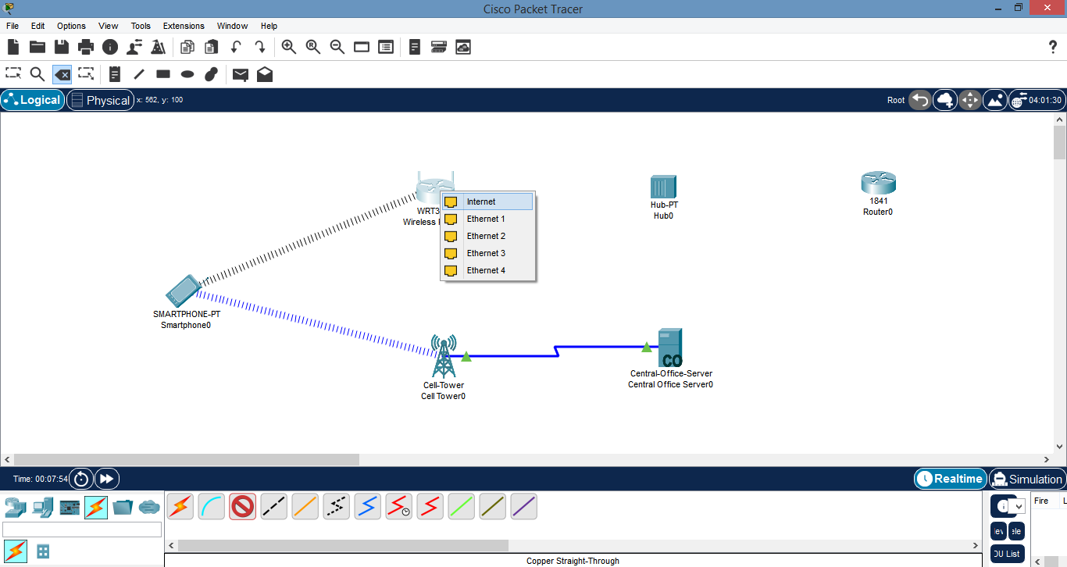

**3]** Connect wireless router WRT300N, Hub-pt, 1841 Router, central-office-server using copper straight through wire.

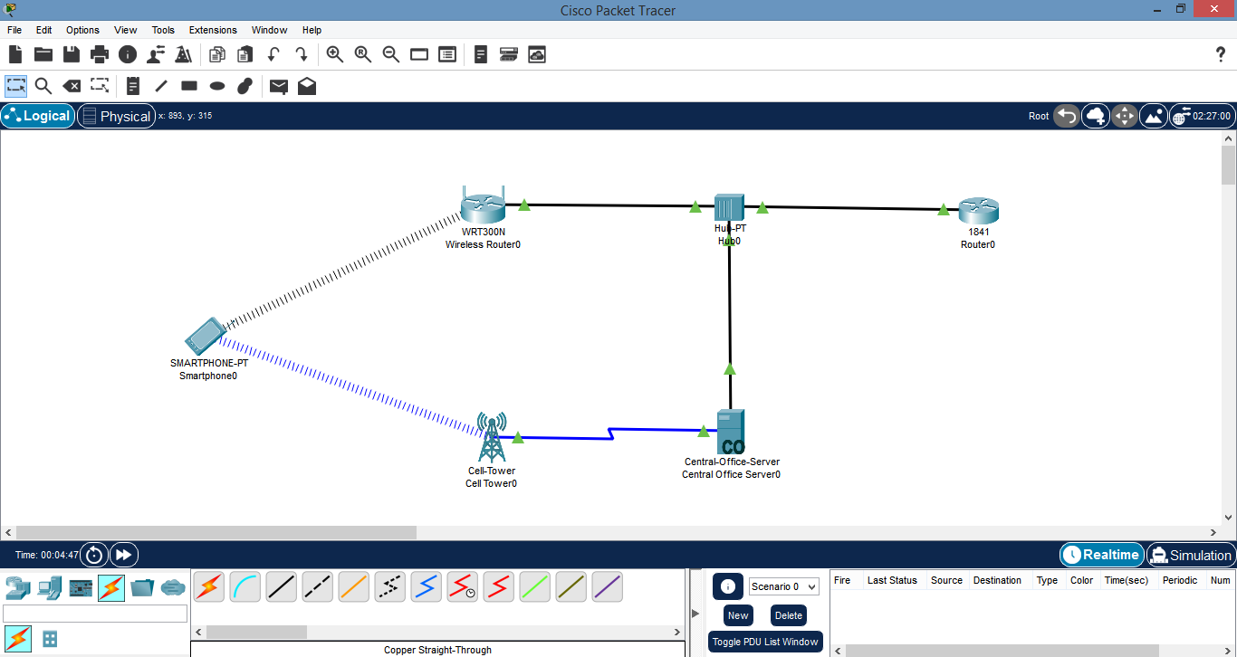

**4]** Click on wireless router.in config tab select internet.in internet choose IP configuration as static and set IP address and default gateway.

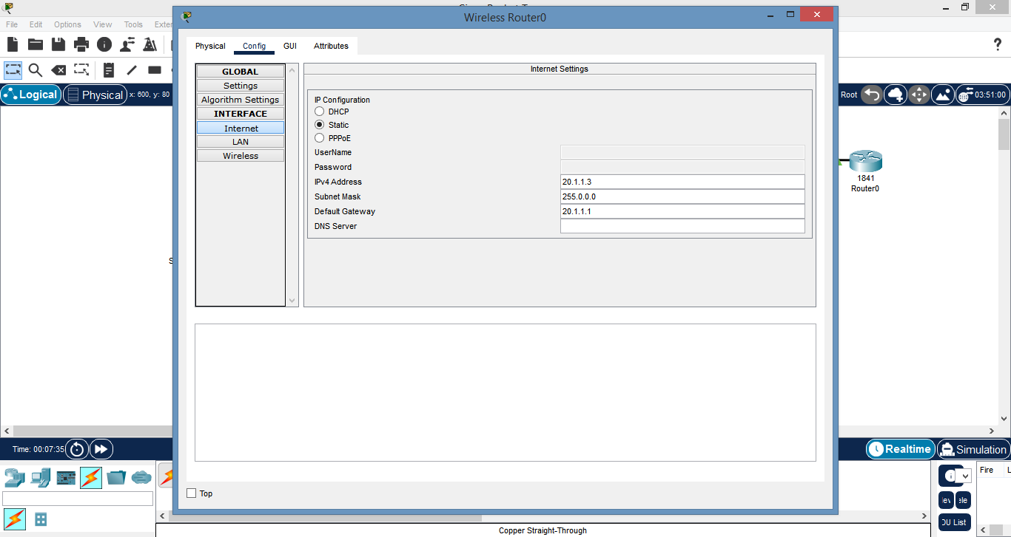

**5]** Click on router 1841. In config tab select interface and give IP address.

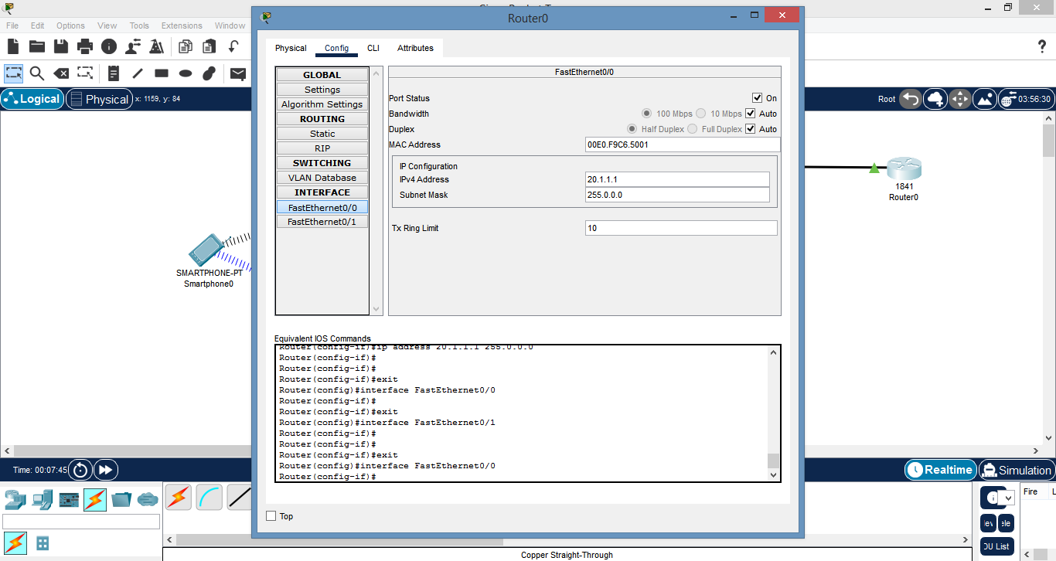

**6]** Click on smartphone and ping router 1841. If pinging succeeds then we will get the ultimate output as.

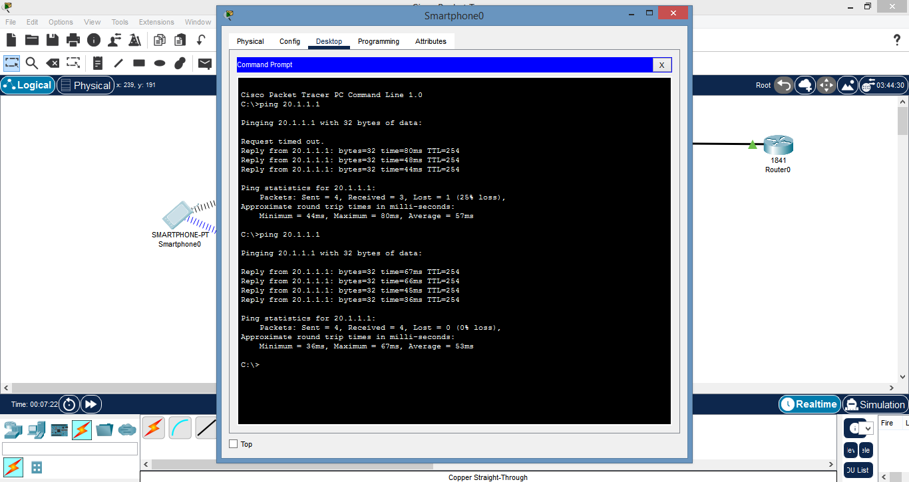

**PRACTICAL NO: - 8**

**Aim:** Understanding, Reading & Analyzing, Routing Table of the Network.

**Requirements:** 2 PC (PT), 2 ROUTERS (PT), 1 COPPER-CROSS-OVER WIRE, 1 SERIAL DCE WIRE.

**STEPS:**

**1]** Connect PC 0 to Router 0 by Copper-Cross-Over Wire and choose the port

Fast Ethernet.

**2]** Then connect Router 0 to Router 1 by Serial DCE (port serial).

**3]** Similarly connect PC 1 to Router 1 by Copper-Cross-Overwire.

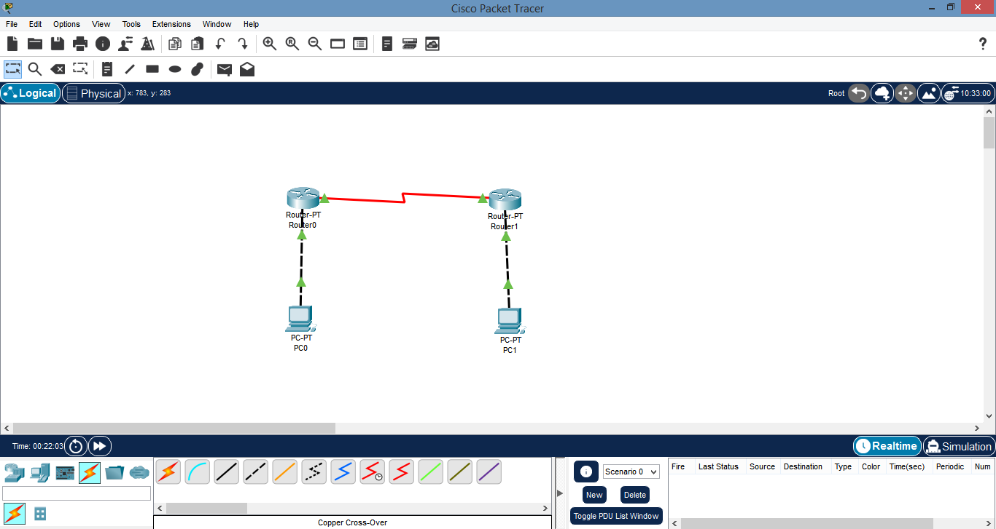

**4]** Then click on PC 0 and set the IP in Fast Ethernet0 section.

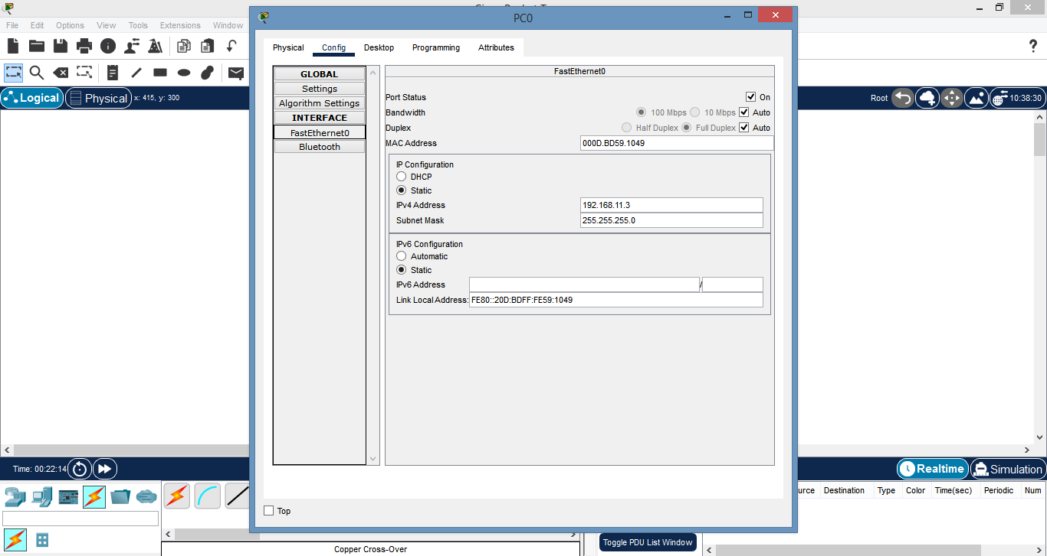

**5]** Make the same changes in Router 0.

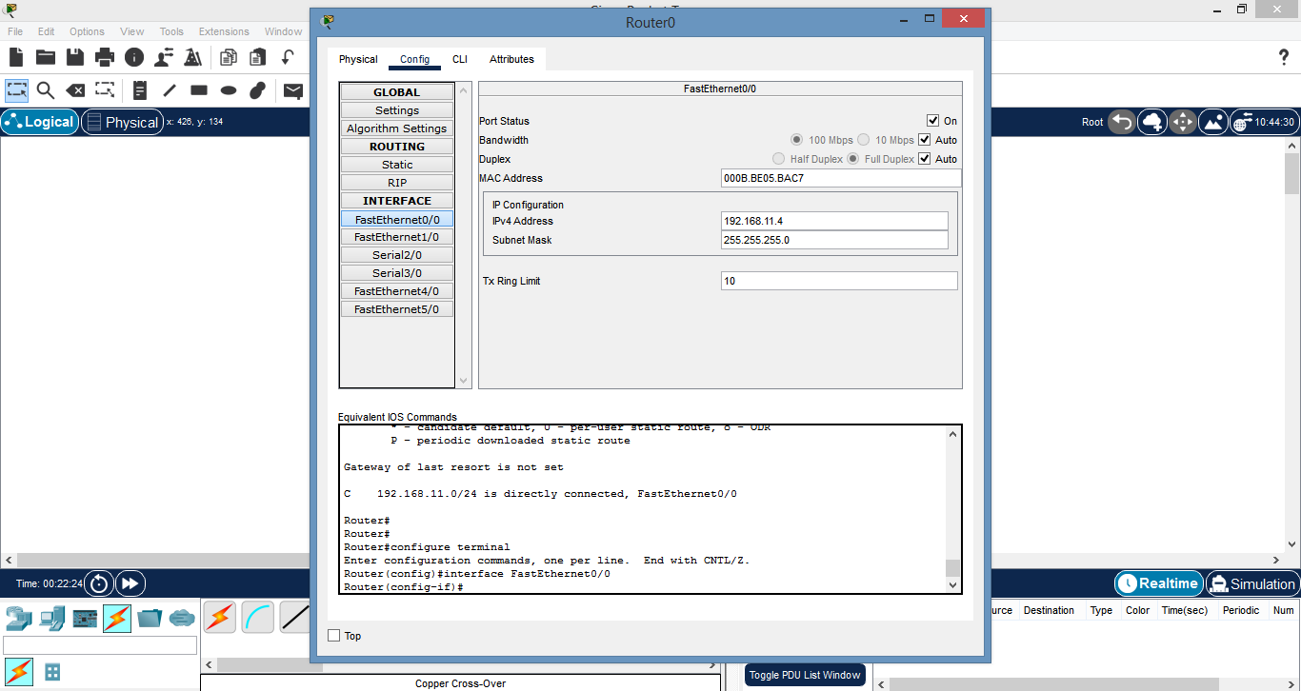

**6]** Also set the IP addresses of PC 1 & Router 1.

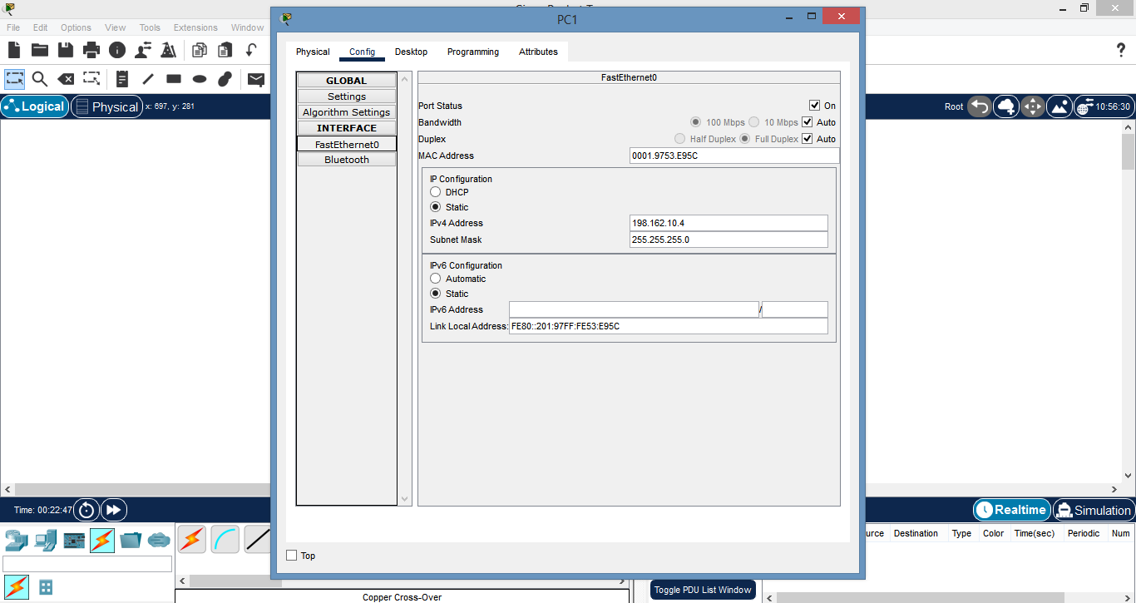

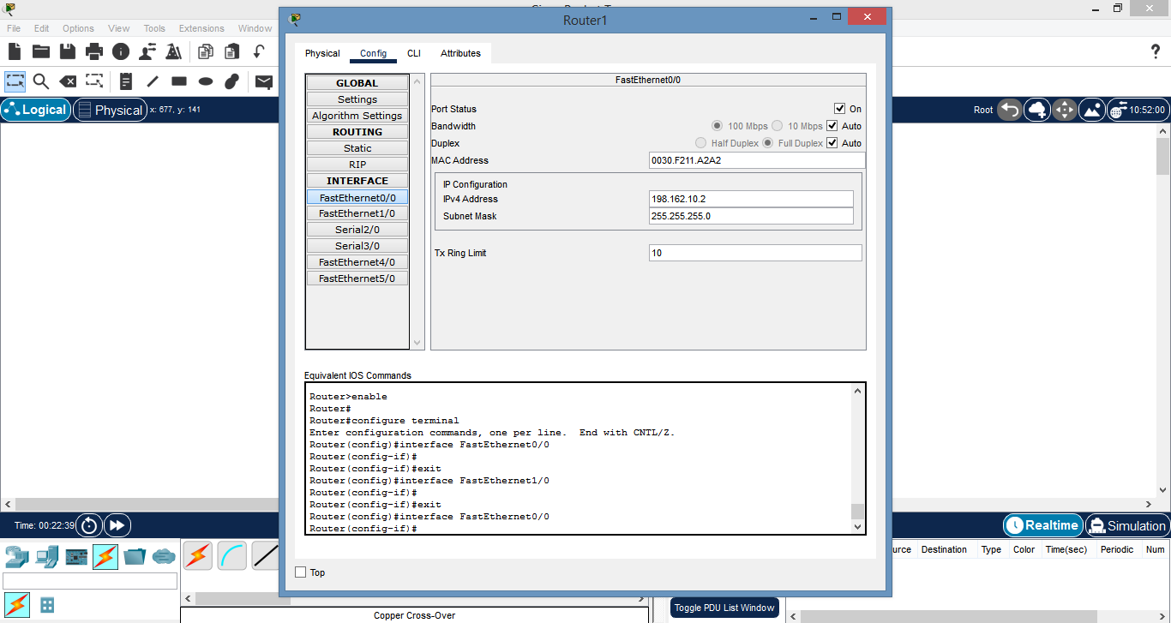

**7]** After changing the IP go in the desktop of PC 1 & click on command prompt

then type “*ping* *IP* *of* *Router* *0*” the pinging must succeed.

**8]** Then go in the CLI of the Router 0 & type command “*#* *sh ip route*”.

